**Module 2 – VBA Scripting**

Quarter 1

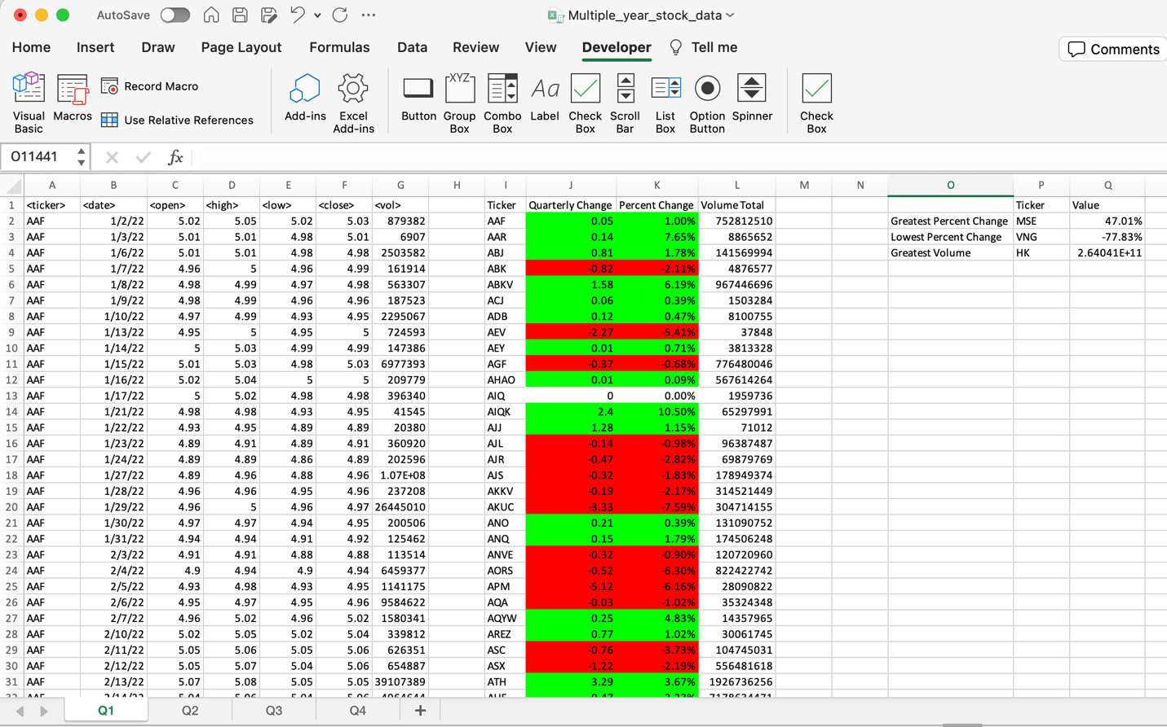

Quarter 2

Quarter 3

Quarter 4

